**Chapter 6 Assembly Language Programming**

* instruuction

-opcode 操作码

-operand 操作数

Modes of Addressing

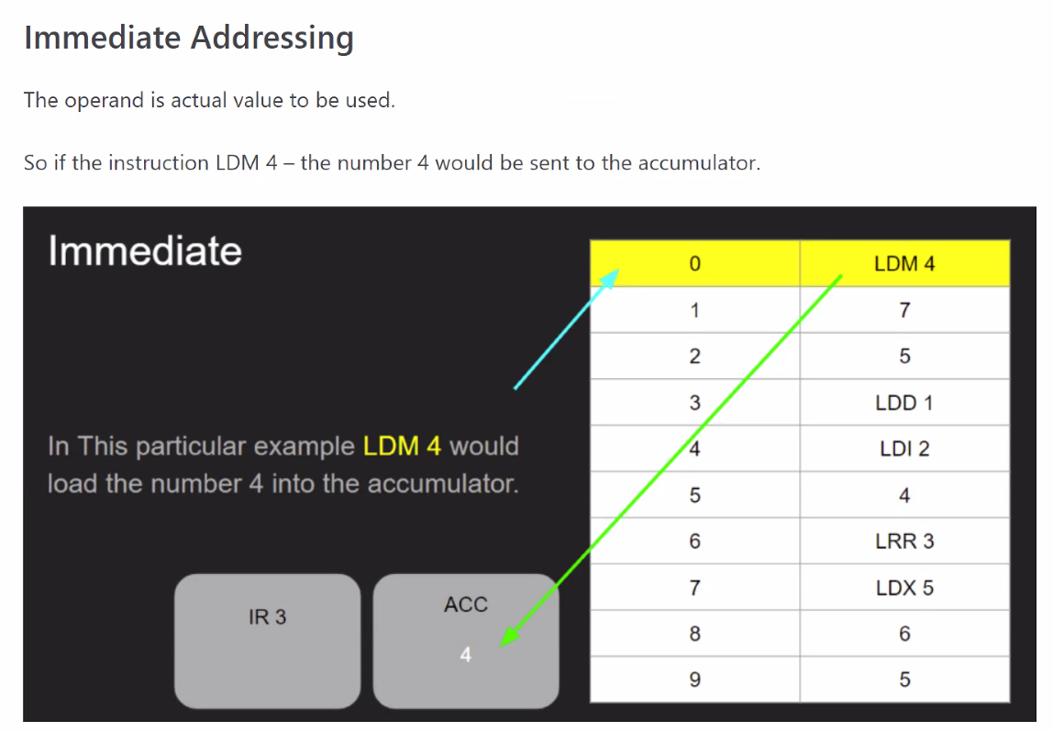

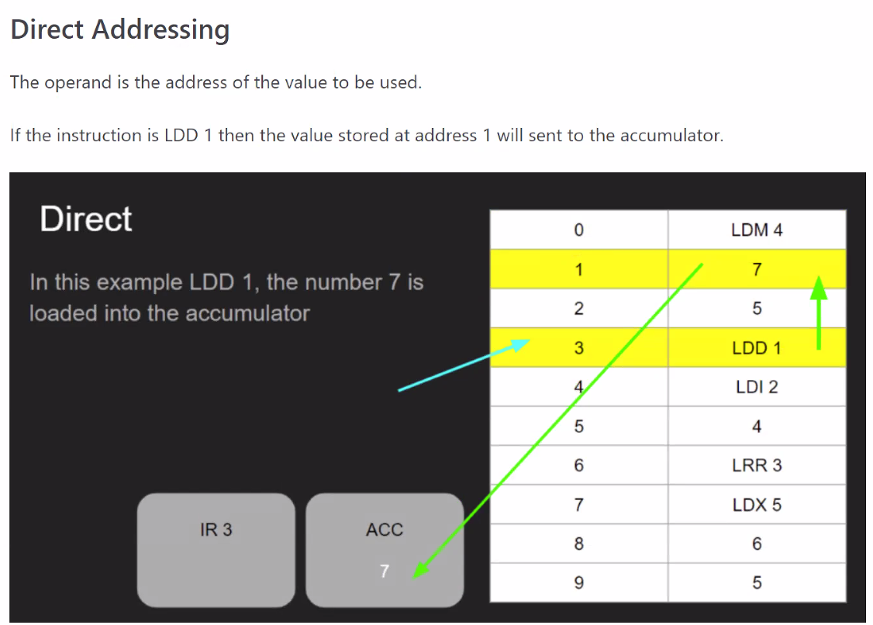

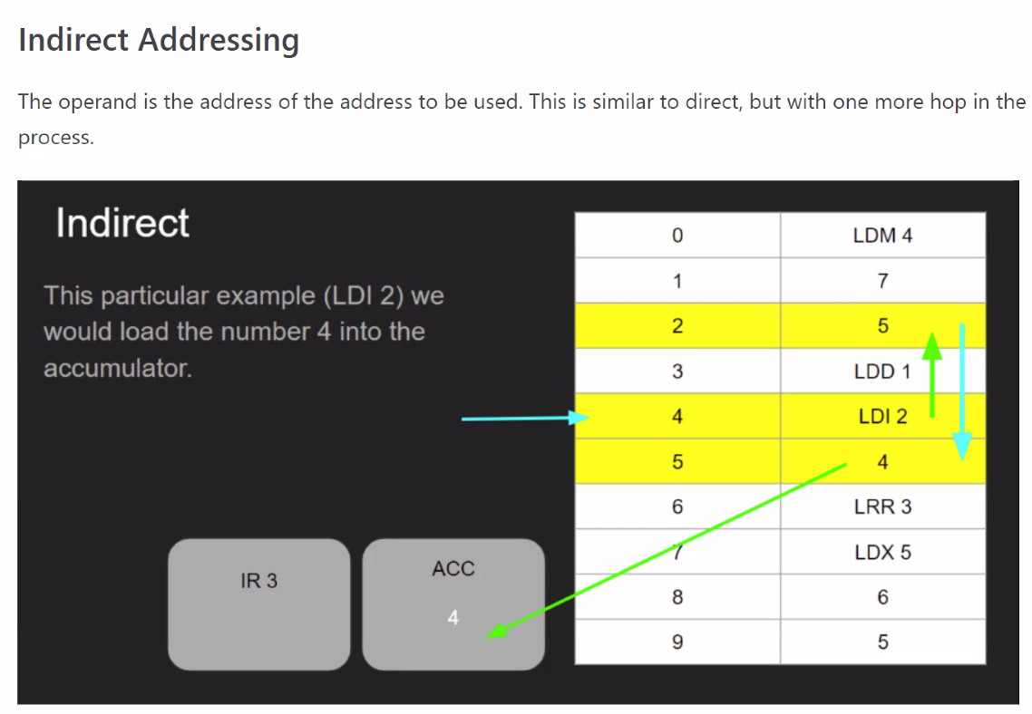

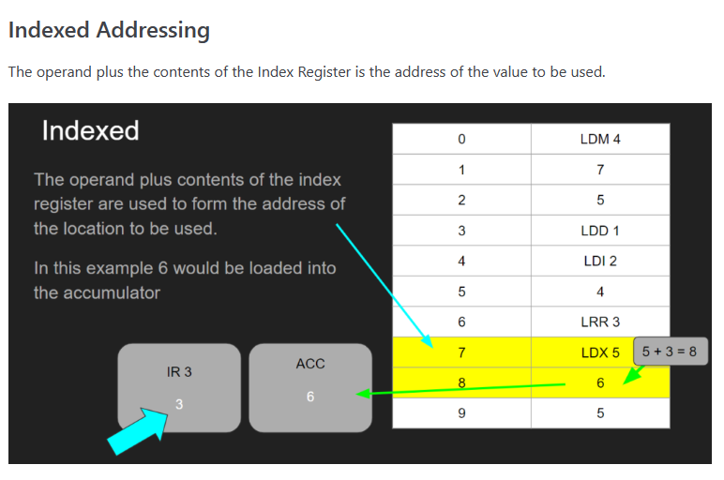

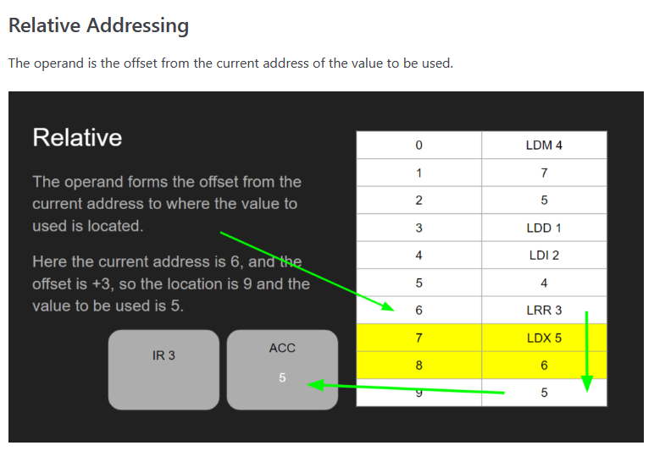

allow for re-locatable code

任何数和1相AND 保持不变

任何数和0相AND 归零

任何数和1相OR 都会变成1

任何数和0相OR 保持不变

任何数和1相XOR 会反过来

任何数和0相XOR 保持不变

LSL:LOGICAL SHIFT LEFT-MULT BY 2^N

LSR:LOGICAL SHIFT RIGHT-DIVID BY 2^N

INSTRUCTION TYPES

DATA MOVEMENT:

LDM LDR LDD LDI LDX MOV STO

INPUT AND OUTPUT

IN OUT

COMPARISON

JUMP

* CONDITIONAL
* UNCONDITIONAL

ARITHMETIC OPERATION:

ADD SUB INC DEC